**8 Hours of Learning Git and GitHub with Sir Vimal Daga**

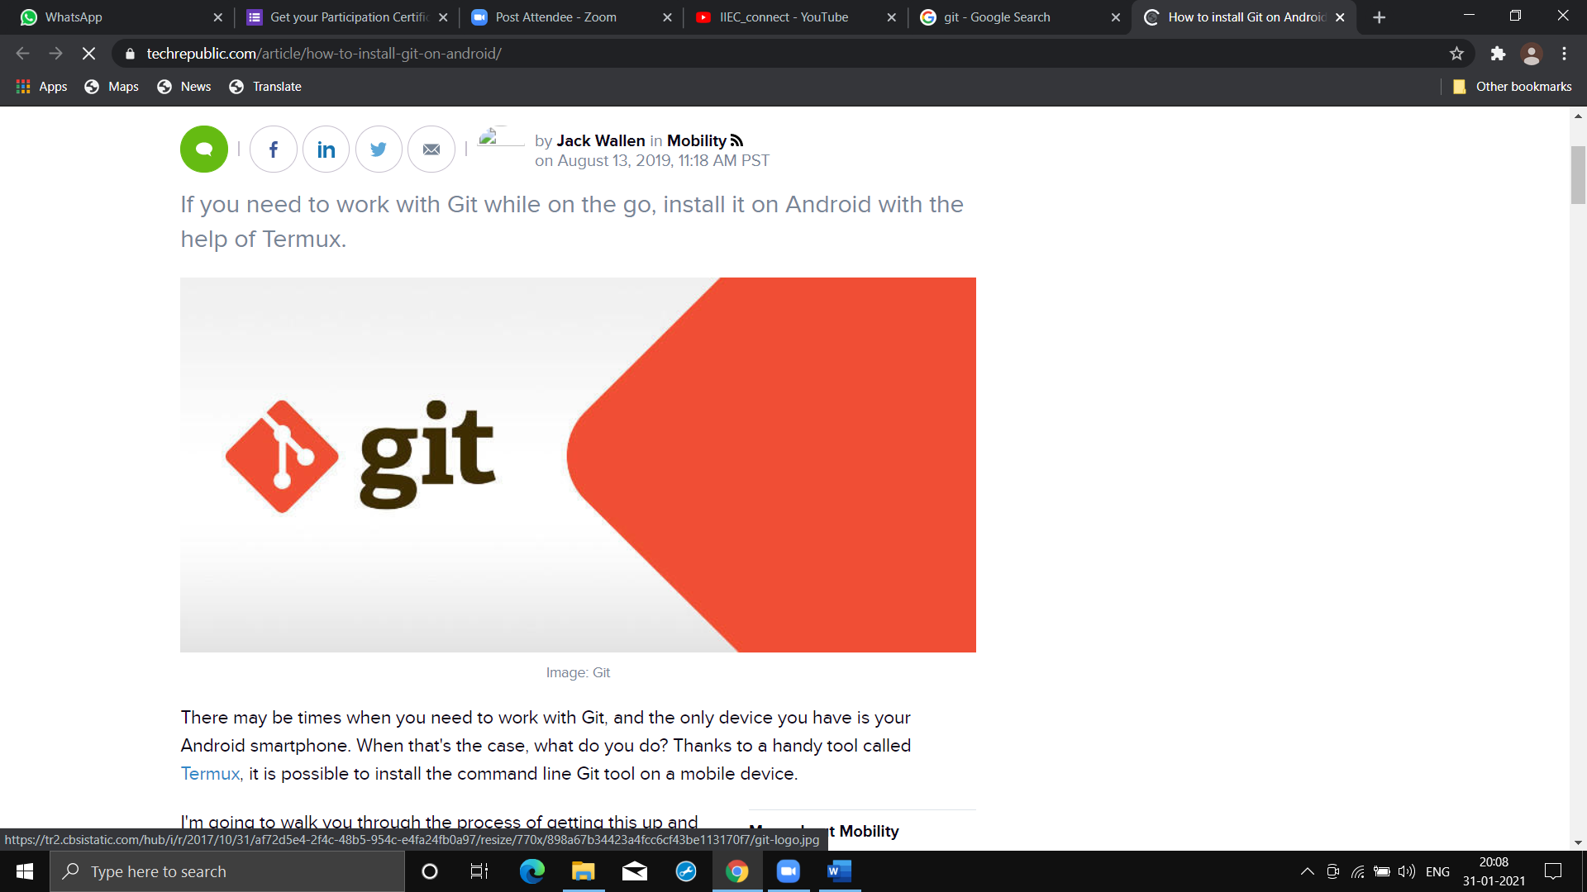

**-It’s 100% true that, “Vimal Sir is the ocean of knowledge!!!”**

**I was actually didn’t have any knowledge about any VCS & not even knowing what it mean. But, after this workshop or rather “training” I am very comfortable with git & GitHub & it only because of my mentor. I am really thank full to “Sir VIMAL DAGA”(My GURU).**

**I have just list out summary of things which I have learnt in this workshop or rather training:**

⭕SCM(Source Code Managment) tool is the one which helps us managing our source code & one of it feature is VCS

⭕VCS(Version Control System) is one of the feature of SCM which helps us to create & manage different version of our code

⭕Backup means storing all the data as many times as backup is created where as "snapshot" means storing all the data only for the first time & then whenever we take snapshot it means storing only newly added, edited or deleted data with respect to previous backup data

⭕Staging area means we are setting up tracker on our files so that after the most recent commit if any changes occur they will find it which would be helping in creation of snapshot & commit area is the one where all the snapshot are stored

⭕Gitbash is the local VCS where as github is a cloud based platform where we can save & share out local repos with internet or keep it private

⭕To do rollback in git use "reset" keyword then commit_ id & then use git checkout -- filename

⭕Branching means creating copy of master branch with its respective storage so that new feature can be added & tested with out hindering the master branch which contains the main code

⭕When new feature is ready we add it to master branch its called "merge

⭕Upstream is the one which has more feature then our main code where as down stream is the one where we have less feature than our main code

⭕There r different merging strategies for merging the but by default merging is ff(fast forward)

⭕To upload repo to github we use key word "push" & for downloading repository we use "pull" or "clone"

⭕"fetch" keyword will fetch only the info about different version in repo in github so that we can confirm that our current code would not create problem while merging. We can see this by using "status" keyword

⭕"pull" keyword will download data from repo of github merge with the master branch

⭕"clone" keyword will download complet repo from github diff tool are the one which helps in visualise difference between 2 versions

⭕To set configuration use git config --global -e command

⭕Webhooks are hooks for github which provide us file for writing script & creates internal trigger for executing those script

⭕Gitkraken is gui for git bash & all the fuxn of git bash are provided by kraken

⭕Squash means most updated version of feature branch is copied to workspace of master branch

⭕Rebase is used to update the base of feature branch if master has done some changes after creation of branch whereas merge is used to copy all data from feature branch to master branch

⭕Fastforward merging strategy is used when linear structure of branch is formed whereas recursion strategy is used when there is non linear structure

⭕Cherry-pick means merging only few version of feature branch instead of merging all the data of branch used when feature branch is under developing & few version has been develop

⭕Stash is like temporary memory in which we can store incomplete work because we need to merge data with master branch but we dont want to merge incomplete work

⭕P4vinst64 is gui tool for resolving merge conflicts

⭕Type of reset are soft,mixed & hard

⭕DVCS means distributed versions control system When ever we install git in our system it internally creates git server for us so that we can create personal git network known as DVSC

**Sir also taught many GUI tools for visualising merge conflicts & branch structure!!!**

⭕**Snapshots of some of the practical which I did:**

